Develop a vb project to condense the given number into a single digit

Form design:

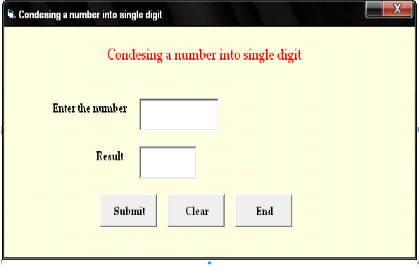

Properties:

Controls | Name | Caption
Text1 | Text1
Text2 | Text2
Command1 | Cmdsubmit | Submit
Command2 | Cmdclear | Clear
Command3 | Cmdend | End

4.Condensing a number into single number

Aim:
To develop a VBProject to condense the given number into a single digit

Coding:
Private Sub Cmdsubmit_Click()
Dim a, b, c As Integer
a = Val(Text1.Text)
b = 0
c = 0
While (a > 10)
While (a > 10)
c = a Mod 10
a = Int(a / 10)
b = b + c
Wend
a = a + b
b = 0
Wend
If (a = 10) Then
Text2.Text = 1
Else
Text2.Text = a
End If
End Sub

Private Sub Cmdclear_Click()
Text1.Text = " "
Text2.Text = " "
End Sub

Private Sub Cmdend_Click()
End
End Sub

Output:

